Victor Vicente

GAMLE3 – Exercise 4 Stealth map

Table of Contents

Basics: 2

Explanations 2

Overview and planning: 2

Multiple paths – solutions 2

Limited Combat 2

Line of sight 2

Guards 3

Environmental story telling 3

‘Realistic’ Scale 3

4, 3, 2, 1 4

4 obstacles: 4

3 Powers 4

2 Story pieces 4

1 Puzzle 4

Submission 1 requirements: 5

Bubble map: 5

Detailed layout: 6

Detailed design: 7

Balancing criteria: 7

Preview geometry: 7

# Basics:

## Explanations

In this game you are a small fire entity, you start at one of the rooms and have a big overview of what is in front of you since the game is top down.

The main enemies are Ash, these ash enemies don’t like you and want you to become like them. Your goal is to exit the house quietly and sneak past these and other enemies while using some of your powers.

The player has a health bar, that slowly decreases, if this health bar goes down to 0, the player dies. Collect items to increase the health bar or go in the fireplace to regenerate.

Whilst playing you notice that around the house are some elements that indicate what happened. And that maybe you are the bad guy, and the ash enemies are actually trying to protect everyone in the house. Unfortunately, the Ash enemies are not very smart and can’t create a good enough plan to catch you.

What happened in the house for it to be so messy?

(spoiler alert) The people in the house weren’t very nice people, they didn’t clean or take care of the house or small children. When one of the times the mom smoked a cigarette, some things went up in flames, they did their best to put the fire out and did an decent job, but to not get questioned and arrested by the police they fled the country with their child in hand leaving only traces of what really happened in that house. (One piece of environmental story telling is the many cigarettes on the floor smoked by the mom and dad, the other is all of the unpaid bills of the house and even the plush toy of the small child at the exit on the floor.)

## Overview and planning:

Since the game is top down, the player can plan their path well, they can’t see everything ahead of them but a very big part. There are also some puzzle parts that make the player go in and out of rooms to solve them.

## Multiple paths – solutions

In these different rooms there are a few options the player can take to complete the game and rooms. They just need to search for them.

## Limited Combat

To keep the limited combat, I made it so that the player could not hit back, they could only walk and hide behind things but if they get discovered by the enemies, they have a limited amount of time to hide or escape, otherwise they lose. There is no way to killing the ash enemies since they don’t burn anymore.

## Line of sight

The Player can hide behind objects to make sure to not get found or to cover the line of sight of the enemies. The player could also get behind the enemies and follow them, but if the player gets to close, they notice you and kill you instantly.

## Guards

These enemies are the guards, and they want to avoid you doing any more damage, therefore you need to sneak past them and use the fact that they aren’t very smart to your advantage. They have a sight cone. Some walk in a pattern and some simply look around in place. You could also trick them into a room and walk past them in some situations or use your powers to surpass them.

## Environmental story telling

The cigarettes that the mom smoked, and the bills that needed to get paid by the family are the main environmental story telling elements. I also added a third element which is the teddy bear of the child. They dropped it while fleeing the house.

## ‘Realistic’ Scale

The scale I used is quite realistic, but I made the character smaller, so everything seems bigger than normal.

# 4, 3, 2, 1

## 4 obstacles:

**Obstacle 1:** Guards (ash), they guard places, walk and turn around patrolling the area and walk back to their initial spot.

**Obstacle 2**: Fast wind gusts from windows. (you get pushed by it and don’t die, but if you stay on it to long the flame slowly turns off, and you die)

**Obstacle 3:** Water/rain, when the player walks, steps or gets hit by water they instantly die since the flame goes out.

**Obstacle 4:** A playful cat that has been living in the abandoned house only wants to play but is too big for the player. The player dies as soon as they get hit by the cat. (this enemy is faster and relentless unlike the ash. When seen by the cat you can’t escape at all)

## 3 Powers

The player can collect all of these powers and keep them like an inventory but only one of each at once. They spawn with no powers.

**Power 1:** cigarette buds lying there can be lit by you and add to your health.

**Power 2:** Dust bunnies jumping around happily can be brutally burnt by the player and thrown places to distract the enemies.

**Power 3:** Wood chips that you can light a fire and throw to teleport yourself over or simply to other places, can be used to your advantage. (you turn into the burning wood chip when you throw it)

## 2 Story pieces

**Story piece 1:** Thefirst element are cigarette buds lying on the floor scattered everywhere, they are burnt showing that the mom didn’t care at all about the house.

**Story piece 2:** The second element are the bills and papers to be paid scattered all over the house that partly got burnt down during the fire.

**Bonus:** The child’s lost teddy bear that started to melt because of the fire. It got dropped at the end of the map.

## 1 Puzzle

Room 2 (corridor) there is no way to pass the guards (or is there?)

Here you need to distract the guards to get past them, you can do this by collecting the dust bunny and throwing it towards the plants, for example to make the enemies walk to that room to try and put the fire out. Or you could collect it and throw it in the corridor.

If you throw it and burn the plants, there is a secret passage to the bathroom that gets revealed.

One additional puzzle is in room 6 with the cat, here you can either distract the cat as well or jump over it with your wood chip power.

# Submission 1 requirements:

## Bubble map:

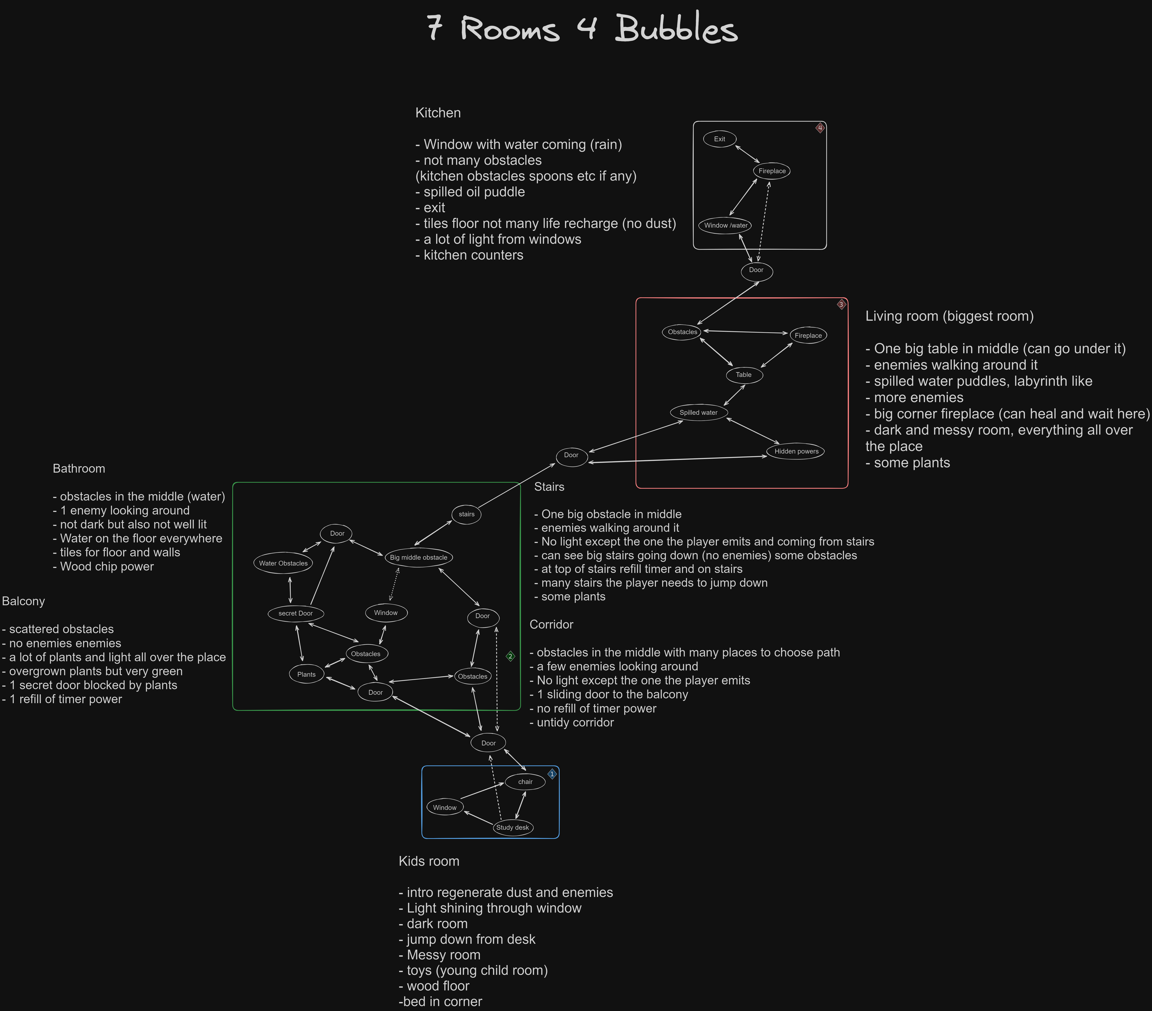

## Detailed layout:

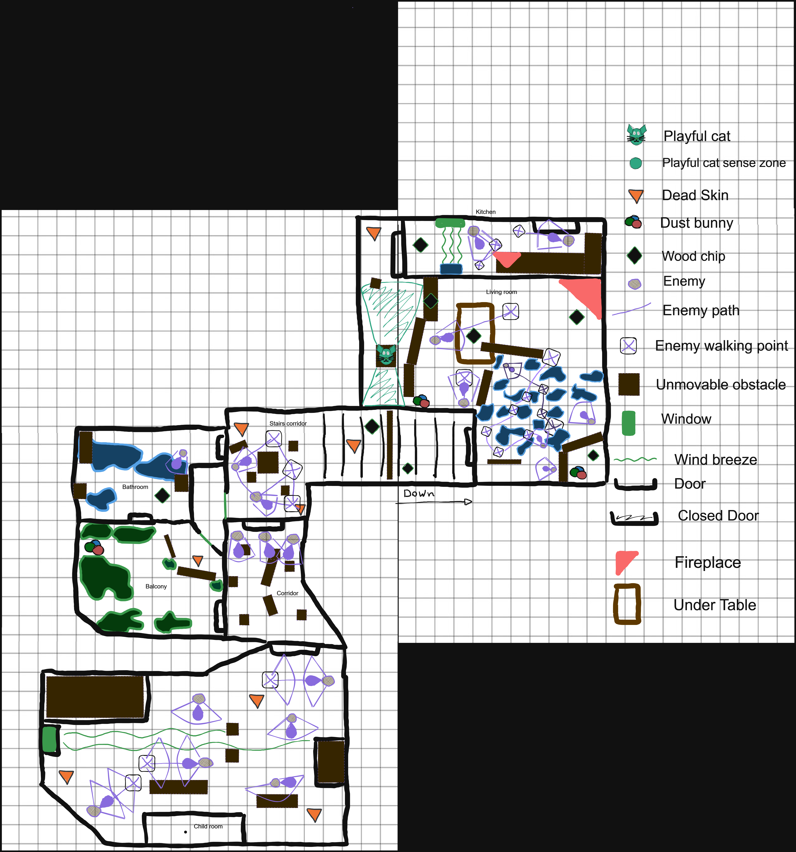

## Detailed design:

All the pickups respawn after 15 seconds when picked up.

The health bar goes down slowly, takes 30 seconds from full to empty.

Adding to it with the cigarette buds power adds 35% of the total to the health bar.

Dust bunnies can be used to distract enemies in a radius of 3 blocks (the big fire in the balcony will call all of the enemies in the corridor since it is a bigger fire)

Wood chips can be thrown at around 5 blocks wide distances max.

## Balancing criteria:

* Guards (ash enemy) can see 3 blocks of distance and is one block wide.
* They rotate 45 degrees in 2 seconds.
* They walk 1 block distance in 2 seconds while patrolling.
* They walk 1 block distance in 1 second while chasing.
* The player can only walk and walks 1 block in 1.5 seconds.
* When the player gets spotted, they have 0.5 seconds to leave the cone otherwise, they die/lose.
* The player gets pushed from the wind at a speed of 2 blocks per second.
* The player can always see at least 8 blocks in distance in every direction.

## Preview geometry:

Room 1: bedroom (messier than this)

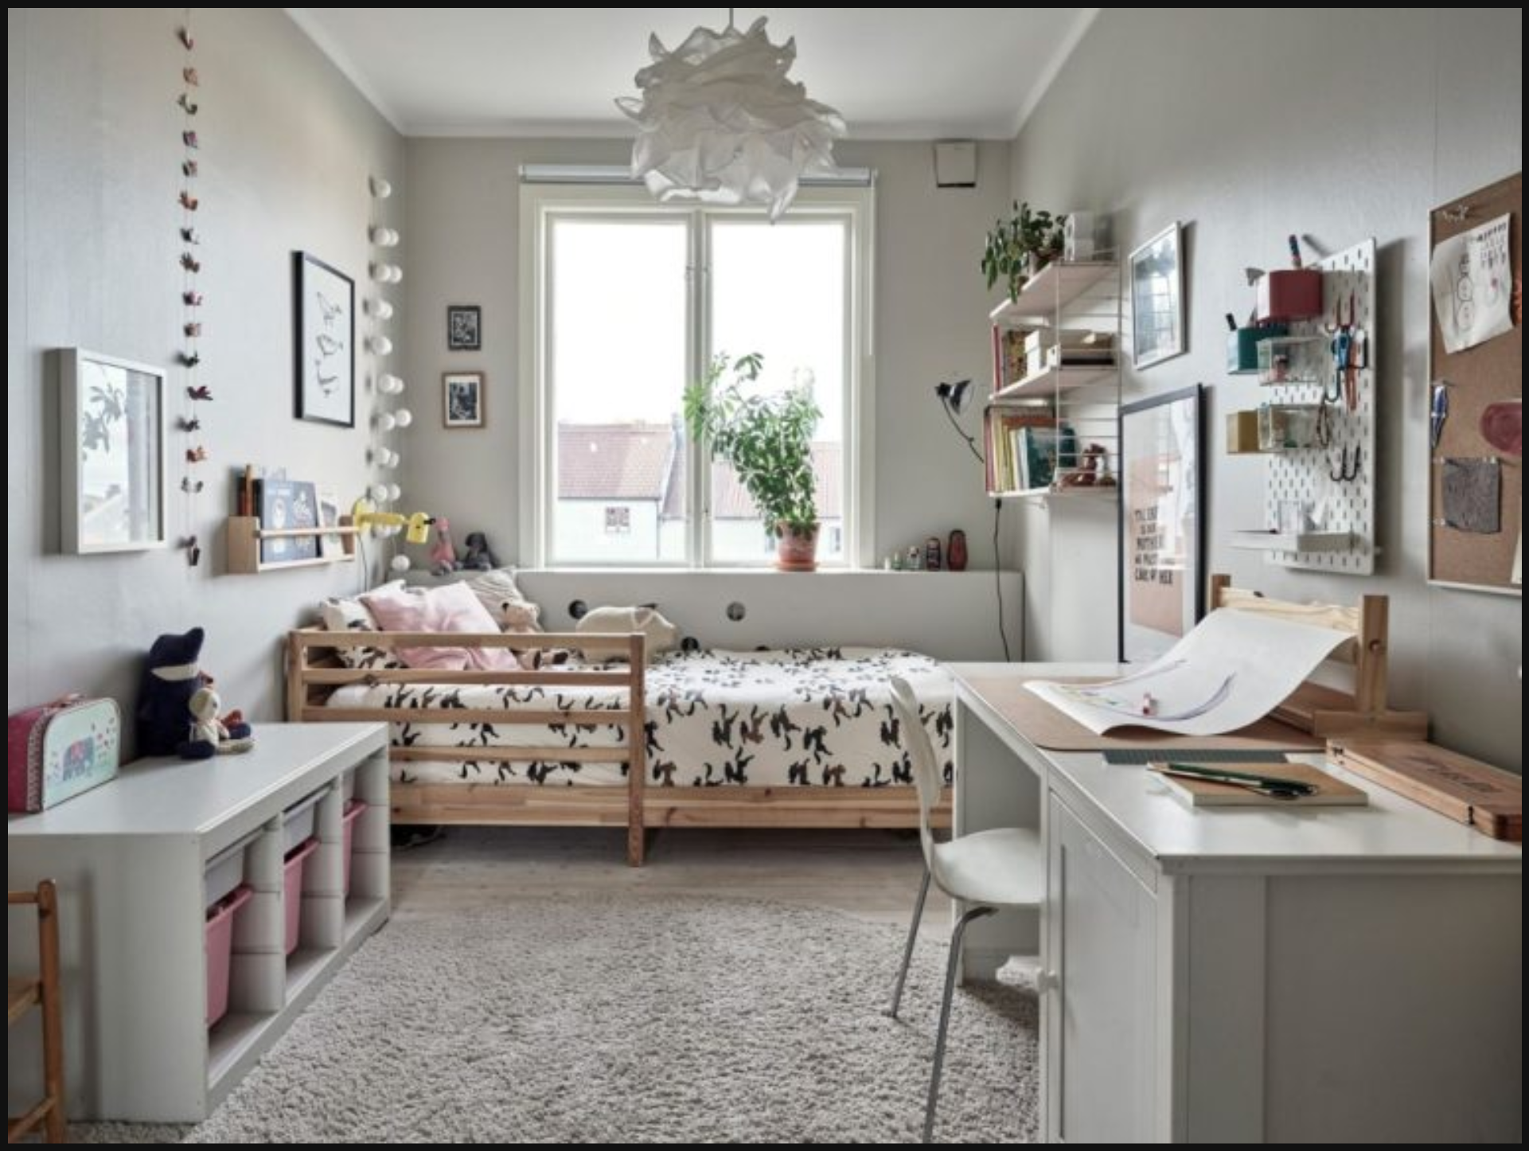

Dust bunny:



Corridor lighting:

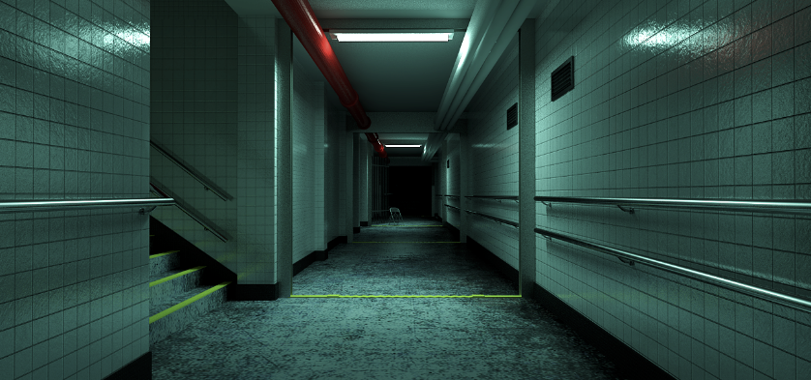

Balcony size and colors:



Water puddles:



Stairs:

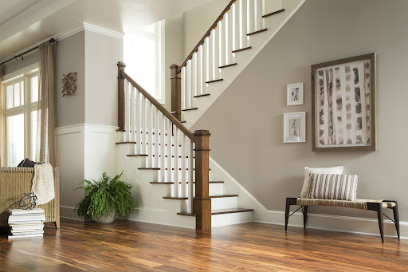

Messy living room:

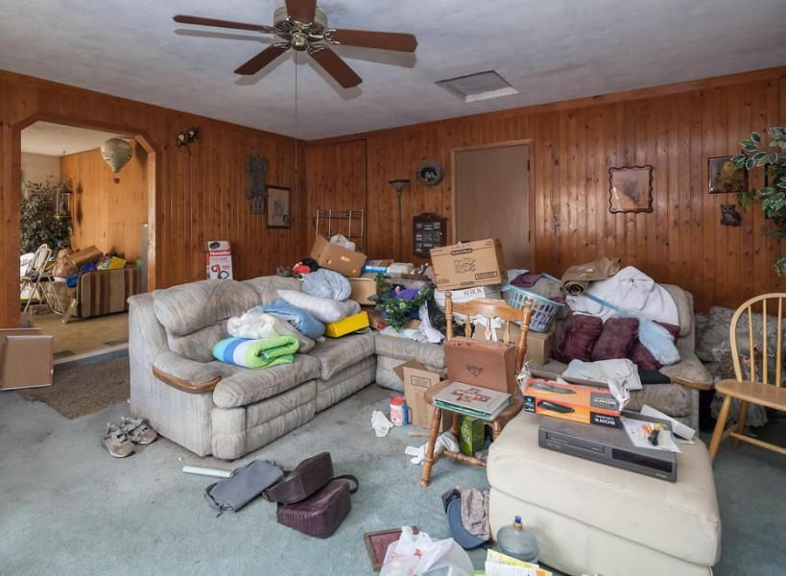

Kitchen (messier with spoons on floor)

